IBM IOT Assignment -2

Python Programming

|  |  |
| --- | --- |
| **Student Name** | Divya Sree K |
| **Roll Number** | 2019504516 |

# Question-1:

Build a Python code, Assume you get temperature and humidity values (generated with random function to a variable) and write a condition to continuously detect alarm in case of high temperature

# Code:

import random

for x in range(0,100):

temp = random.randint(0,100) hum = random.randint(0,70) print("Temperature:",temp) print("Humidity:",hum)

if temp>57 or hum<40: print("Alarm ON")

else:

print("Alarm OFF") print("\n")

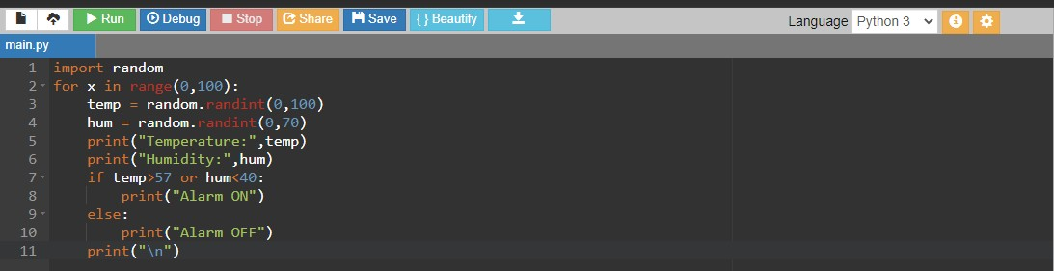

# Output:

